# Ten Best Practices for Academic Success

*Bob Brown  
Copyright © 2020 by Kennesaw State University*

Hello! I’m Bob Brown. I’m retired, but I taught at Southern Polytechnic and Kennesaw State for more than 20 years. I used to give my students some advice on best practices for studying, and some of them found that advice helpful. I made this short video with the hope that it will help others. If you’ve developed an effective regimen for studying keep it up. If not, perhaps these best practices will help you.

## Herbert Simon on Learning

Herbert A. Simon was one of the founders of cognitive science. He was a Nobel Laureate who held joint appointments in psychology and computer science at Carnegie Mellon University. Here’s what Dr. Simon had to say about learning.

Learning results from what the student does and thinks and *only* from what the student does and thinks. The teacher can advance learning only by influencing what the student does to learn.

In other words, your professors can help you and guide you but learning is entirely up to you.

What can you do to enhance your learning? Interacting with the material multiple times is a key technique.

## Memory and Learning

If you remember one thing about these best practices, remember re-use of information. Psychologists call this “rehearsal.” The goal of studying is to move information from your short term memory to your long-term memory. To do that, you need to use the material at least four times with increasing time between exposures.

That means cramming doesn’t work. You have to space out your studying. Doing that will make you less stressed, too. Simply glancing at the material doesn’t work. You must actually use and think about it, relating new information to what you already know to form associative cues, which is why psychologists call this rehearsal.

The following information about learning is necessarily highly simplified. The purpose is to explain why you should do these things and not to be a study of memory models.

Let’s look at something called the Atkinson-Shiffrin memory model. The model was proposed in 1968 by, as you might expect, Atkinson and Shiffrin, and changed in enhanced for several years afterward. There are more recent theories of memory and not all psychologists agree about how this works. Even so, this model can help us understand what we need to do to learn effectively.

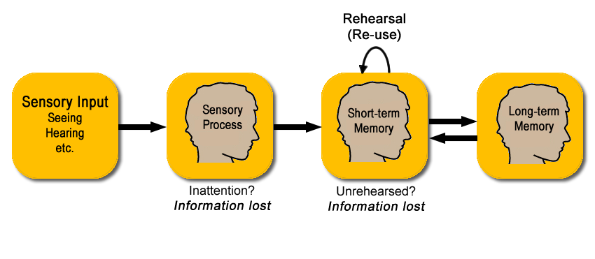

We get a huge amount of input from our senses. For most of us most of the input comes through our eyes and ears. We don’t retain all of it. In fact most of it is lost immediately. The sensory process in our brains "filters in" those inputs that have our attention and discards the rest. So, if you’re reading a compelling text message in class, what the professor is saying at the time is lost.

Those sensory inputs which have our attention are committed to short-term memory. To move information from short-term memory to long-term memory requires rehearsal, that is, reusing the information.

The capacity of long-term memory seems to be unbounded. Information is returned to short-term memory for use through associative cues such as an exam or a quiz question or another situation that requires information that we’ve learned previously.

Onward to the best practices!

## Engage with your classes

Attend and engage with your classes. Your classes may be face-to-face or online. It doesn’t matter. You must keep up with the pace of the class. In fact, asynchronous online classes are harder than classes with established meeting times because they require more self-discipline.

In any setting, whether online or face-to-face, you’ll have more and better interactions with your professors and fellow students if you are present and engaged. Attending class is not a decision to make. It’s something that you need to do.

## Do the homework

Do the homework. Professors do not assign homework to get the answers. In nearly every case the professor already knows the answers. Yes, I’ve made mistakes and assigned problems I didn’t know the answers to, but not very often. The purposes of homework are to let you practice the things you’re learning and to demonstrate that you know the material. While you’re working on the homework, analyze what the professor expects you to learn from each part of the assignment and be sure you’re focused on the objective. Is it for proficiency practice? Concept formation? To develop the ability to combine ideas? ... and so on. And remember, you’re likely to find similar material on the exams. So, do the homework.

## Find a quiet place and time to study

Find a quiet place and time to study and make studying a daily habit, like working out or practicing music. Studying should be free from distractions. That means put away your phone! Music will distract, too. That’s why they play music in dentists’ offices. If you need to mask distracting sounds try white noise.

## Read the assigned material before class.

If you’re given a reading assignment do it, *before* class and take notes of the important points. Yes, the professor is going to tell you most of it in class or present notes online, but usually the author of the material and the professor are different people, so you get two points of view on the same material and, if you’re engaged you get re-use. Don’t promise yourself that you’ll read it later because mostly that doesn’t happen.

## In class, you should be listening

In class *listen* instead of messing around with your gear. You may have convinced yourself that you can multitask and still absorb the material. If so, you’d be wrong! A study at Bryan College showed that multitasking during cognitive tasks lowers IQ by 15 points. I don’t know about you, but I don’t have 15 points to spare.

## Ask questions

If something you read or something the professor says is unclear, ask! If you have a question about something, probably so do others. Professors appreciate thoughtful questions. Asking helps you helps you, helps the professor, and helps your classmates. If you have a question about the material from the reading, hold until the class reaches that part of the material so that you can ask it in context.

## Make notes on paper

In reading or if the professor says something that sounds important, especially if it’s not already in the class material or if the professor repeats, it you should probably jot it down *on paper*. Why paper? Professors Pam Mueller at Princeton and Daniel Oppenheimer at UCLA did a study that showed that taking notes on paper is more effective for learning than using a laptop.

## Merge your notes onto the slides the following day

On the day after class, merge your reading notes and the class notes onto the printed slides or class material. The first time I told a class that, some people just got irate and asked, “Why should we do extra work when we could just take notes on the slides?” First, if you bring printed notes to class, you’ll find them a distraction from what the professor is saying. Second, think about what you’re trying to do. You’re trying to move information from short-term memory into long-term memory and what does that is re-use of the information spaced out in time.

So, when you take those notes from the previous day and copy them onto the slides or printed material, you’ve re-used the information. You’ve done some of that work that it takes to move information from short-term memory to long-term memory.

## Each class day, review the slides and notes from the class one week ago and skim the reading

Each class day, review the class material and your notes from the class one week ago, and review the assigned reading. That spaces out exposure even further and gives you another round of re use for moving things from short-term memory to long-term memory.

## Learn from graded material

After you get back each graded assignment, homework, or test, look at the work you missed to be sure you understand the answer that was expected and ask yourself what was lacking in your studying regimen that made you miss that item. If necessary, adjust your studying regimen.

## The best practices

If you follow these best practices:

* engage with your classes,
* do the homework,
* study at the same time and in a distraction free place,
* read the assigned material *before* class,
* *listen* in class,
* ask questions,
* take notes in class,
* merge the notes on to the material the professor provides,
* study your merged notes a week later, and
* learn from the graded material,

you’ve gotten four or maybe five licks at the material without really doing very much work other than what you should have been doing anyway. By dividing it up into chunks, you stand a much better chance of remembering it, at least until the exam and maybe even remembering it long enough to use in your career.

This works in every class you take. If you do this, you’ll learn more and as a side benefit, maybe make better grades.

I enjoyed making this video and I hope you found it helpful and useful.